IDEA DISCLOSURE FORM (IDF)

This IDF is intended to help Applicants provide information for Design search/Design Registration. Needless to say, the response to this IDF will be treated as Confidential Information and not disclosed to people other than those involved in evaluation of its subject-matter.
Note: Please provide as much information as possible

- Name, address, and nationality/legal status of the Applicant.

S. No | Name in Full | Nationality | Country of  Residence | Address of the Applicant
1 | Vivekananda Institute of Professional Studies- Technical Campus | Indian | India | Vivekananda Institute of Professional Studies - Technical Campus, Delhi-110034, India
2 | Dr. Divya Agarwal | Indian | India | Assistant Professor, School of Engineering & Technology, Vivekananda Institute of Professional Studies - Technical Campus, Delhi-110034, India
3 | Anmol Nandwani | Indian | India | Student, School of Engineering & Technology, Vivekananda Institute of Professional Studies - Technical Campus, Delhi-110034, India
4 | Gauri Gupta | Indian | India | Student, School of Engineering & Technology, Vivekananda Institute of Professional Studies - Technical Campus, Delhi-110034, India
5 | Vansh Sharma | Indian | India | Student, School of Engineering & Technology, Vivekananda Institute of Professional Studies - Technical Campus, Delhi-110034, India
- Name, address, and nationality of the designer/inventor (required in case of filing in Foreign Countries).
- ……………………………………………………………………..
- ……………………………………….
- ………………………………………

- Title of the article “Arogya AI: Portable Multi-Modal Edge-AI Diagnostic Device for Rural Healthcare "

- Use of article
This article targets the needs of point-of-care health triaging and initial diagnosis in rural and resource-limited settings. Its purpose is to be utilized by front-line health care professionals (ASHA workers) to:
• Gather various physiological and biochemical measurements
• Facilitate health screening immediately after acquiring the data without the use of laboratories or internet connectivity
• Perform multi-modal health screening incorporating cardiopulmonary, thermal, spectral, and environmental sensing
• Facilitate objective decision-making at the point of care
• Do AI-based triage in the absence of internet connection using TinyML algorithms
• Apply the Deep Scan method for acquiring noise-free data
• Demonstrate real-time data acquired by displaying them on an OLED display and Red/Green LEDs
• Conduct tests for common diseases such as fever, hypoxia, arrhythmia, respiratory problems, and anaemia.

- Brief Description of the design of the article:
  - Purpose/use of the article:
The suggested article involves a miniature diagnostic tool which contains several different types of sensors that are assembled in one compact enclosure, providing a full-scale health check in outdoor conditions. These include:
- Cardiopulmonary sensors (ECG, SpO₂/PPG, respiration)
- Fever sensor using thermal imaging
- Hemoglobin sensor based on spectral sensing
- Gas sensor and GSR sensor

These sensing systems have been incorporated into a single enclosure and are able to provide on-device inference powered by ESP32-S3 and machine learning models (TinyML). The proposed system provides for the following features:
- Single-user manipulation outside the clinical setting
- Organized access to sensors owing to their positioning
- Output in real-time using OLED and LEDs
- Offline functionality ensuring stability of the system operation in rural settings
- A 60-second “Deep Scan” sequence ensures optimal sensor contact.
  - Novel aspect of the article sought for design protection (please provide a novelty statement of the article)
The uniqueness of the invention is found in the integrated configuration and diagnostics system architecture:

- Configuration of a one-unit, multimodal diagnostic system based on the structural integration of multiple types of sensors (cardiac, respiratory, thermal, spectral, and environmental sensors) into a portable form factor, which is different from a traditional approach to a multi-device configuration.
- Internal system architecture, integrating I²C, SPI, and analog sensor interfaces via the embedded system, making possible spatial and functional integration of the system into the small housing enclosure.
- Unique design of user interface configuration, consisting of a small OLED display and a triage indicator in the form of a two-color LED light (Red/Green) to enable operation in a zero-literacy environment.
- Integrated physical design according to the workflow-driven rule of interactions between user and device (Idle > Deep scan > Results) ensuring additional stability in measurements and reduction of errors.
- Autonomous diagnostic embedded system, combining all the necessary parts of it (sensor interface, processor, display) inside the housing without using computing capabilities of other devices or the cloud.
- Physical device configuration and design including geometrical design, sensor arrangement and interface optimization for functioning in tough conditions

- Drawings/photographs of the article. Drawings depicting various views of the article covering at least perspective view, front view, rear view, top view, bottom view, left and right-side view. Application can be filed with line drawings, computer aided drawings or with photographs. Further, please note that under the Indian practice, discrete/discontinuous/broken/shaded lines are generally not allowed in the drawings.

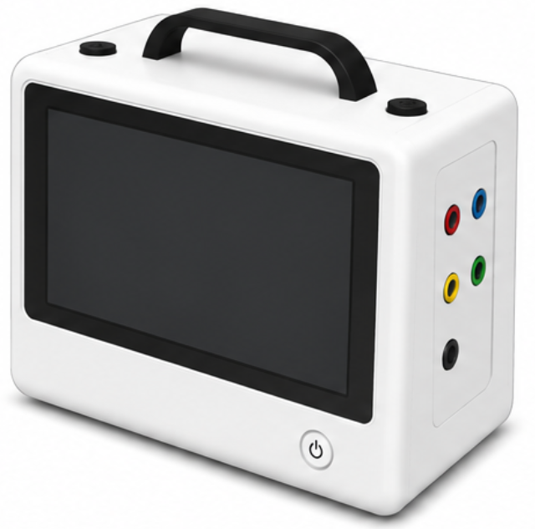
Figure 1: Perspective View
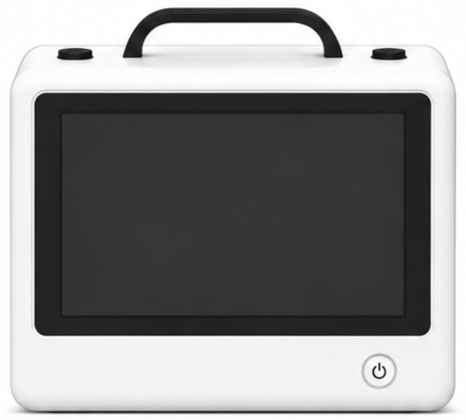
Figure 2: Front View
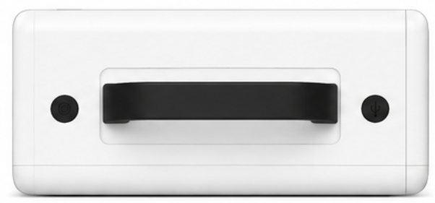
Figure 3: Top View
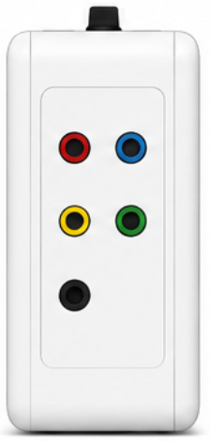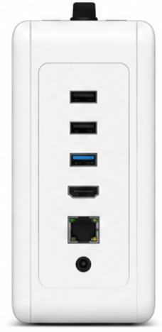
Figure 4: Left View Figure 5: Right-Side View

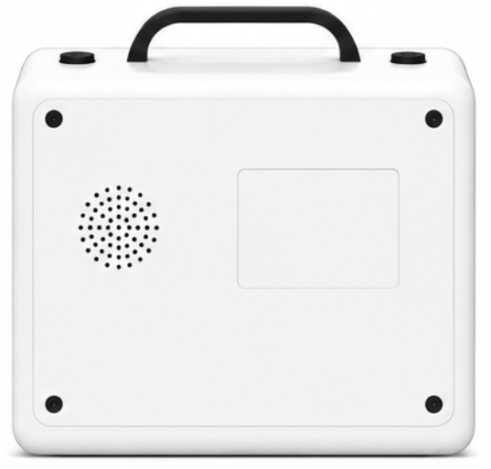
Figure 6: Rear View

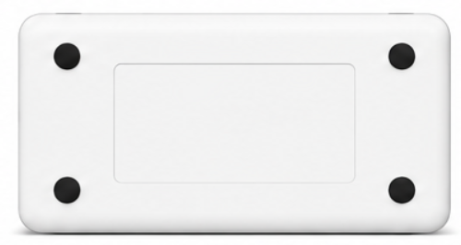
Figure 7: Bottom View

